# Goal

Create an AKS cluster in a VNet.

# Steps

## Login to your Azure Subscription

1. Login to the Azure Portal

Go to http://portal.azure.com and login using the credentials provided.

After logging on click on “Resource Groups” menu option on the left. You will see a Resource Group (RG) pre-created for you with name “Company*”. ‘*’ is your company number.

**Make a note of your company number. You will use this number to create resources throughout the workshop.**

Click on the RG to see all the resources in it. You will see two VNets. The “C*-VNet” is the hub VNet which contains the ER Gateway and Firewall deployment. The “C*-Spoke-VNet” is a spoke VNet peered to the hub and is where you will deploy the cluster.

Resources in these VNets have names beginning with “C*” and “C*-Spoke” respectively.

Below is a snapshot of Company60

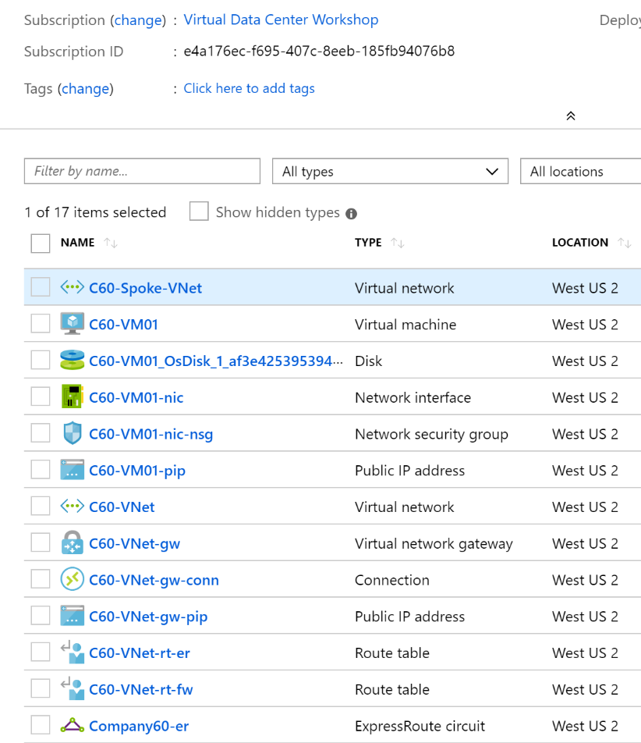

## Create a Cluster

Complete the below steps to create a cluster. We will create it through Azure CLI

**Note: In all these instructions replace ‘*’ in the resource names with your company no.**

1. Open Windows *cmd* prompt
2. Login through CLI

Login through CLI by running the following command. This will open the web browser where you will enter the credentials provided and login to Azure

az login

1. Get the Virtual Network Subnet Resource ID

You will deploy the cluster into the subnet named “Cluster” in the VNet “C*-Spoke-VNet”. Run the following command to get the Resource ID of this subnet and save the output.

az network vnet subnet show -g Company* -n Cluster --vnet-name C*-Spoke-VNet --query id -o tsv

1. Get the Resource ID of the Monitoring Workspace

There is a workspace already created for monitoring in your RG. You will use the same workspace for your AKS cluster logging too. Run the following command to get the Resource ID of your workspace and save the output

az resource show -g Company* -n Company*-Logs –-resource-type Microsoft.OperationalInsights/workspaces –query id -o tsv

1. Create the Cluster

This command will deploy a 3-node cluster into the Cluster subnet. Azure CNI will provide Pod networking and Azure Policies will provide Kubernetes Network Policies.

The highlighted parameters require you to modify the values for your environment. Replace the ‘*’ with your company number.

az aks create --name C*-Spoke-Cluster --resource-group Company* --dns-name-prefix C*-Spoke-Cluster --service-cidr 10.20.0.0/16 --dns-service-ip 10.20.0.10 --docker-bridge-address 172.17.0.1/16 --network-plugin azure --network-policy azure --service-principal 1f7cd1c1-ebdc-4724-8348-eb513f2bddd7 --client-secret +KR73NUhYuf1AuPotU?6.Q?ip3Q*mu=c --vnet-subnet-id <SubnetID_FromStep3> --enable-addons monitoring --workspace-resource-id <ResourceID_FromStep4>

It can take up to 10 minutes to deploy the cluster. You may see an error message saying “Could not create a role assignment for subnet. Are you an Owner on this subscription? “. Ignore the message.

## Verifying the Cluster

Once the cluster is created you will see it in the list of resources in the Resource Group blade. Click on it to get the portal blade for cluster and view the cluster configuration.

Below is a sample for Company59

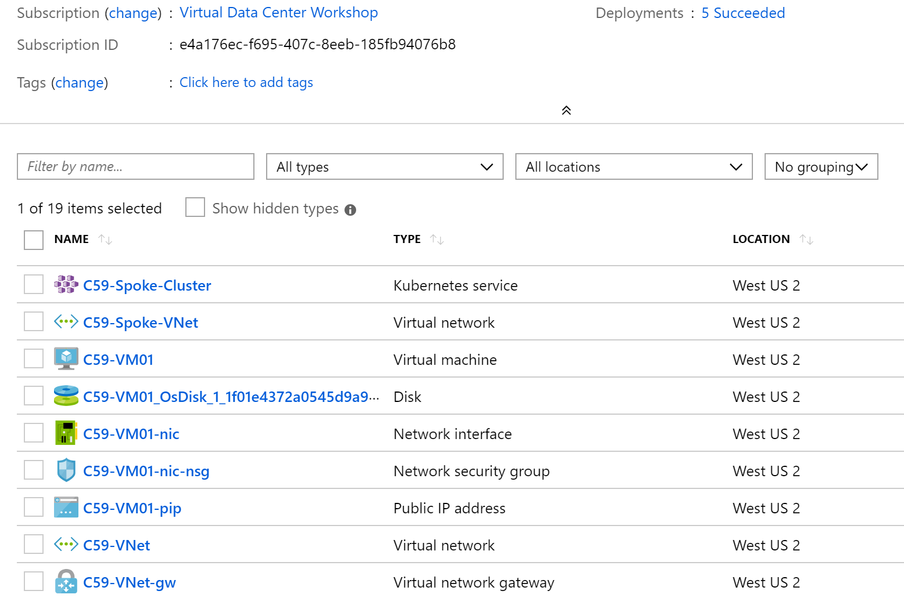

## Install *kubectl* – Kubernetes Command Line

1. Intall *kubectl*

az aks install-cli

1. Get the Credentials to connect to your Cluster

az aks get-credentials --resource-group Company* --name C*-Spoke-Cluster